Project 2 – Secure Network Design and Implementation
Student 1: Ambrose Imagbenikaro
Student 2: Waqas Salman
Student 3: _______________

Introduction
This project demonstrates the design and implementation of a secure enterprise network using multiple routers, switches, and VLAN segmentation. The network was configured using Cisco devices in Packet Tracer.
The goal of the project was to implement:
- VLAN segmentation for different departments
- Inter-VLAN communication using Router-on-a-Stick
- Dynamic routing using OSPF
- Access Control Lists (ACL) for network security
- End-to-end connectivity between hosts
The network contains 3 routers, 3 switches, and 6 PCs representing different departments in an organization.
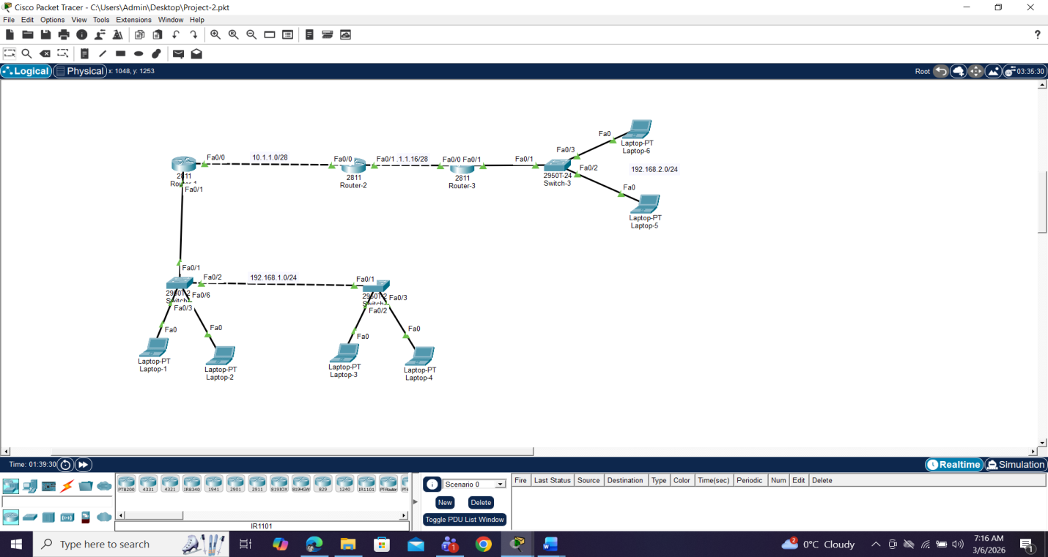

2. Network Topology
Departments are separated using VLANs:
VLAN | Department
VLAN 11 | IT
VLAN 12 | HR
VLAN 31 | SALES
VLAN 32 | MANAGEMENT
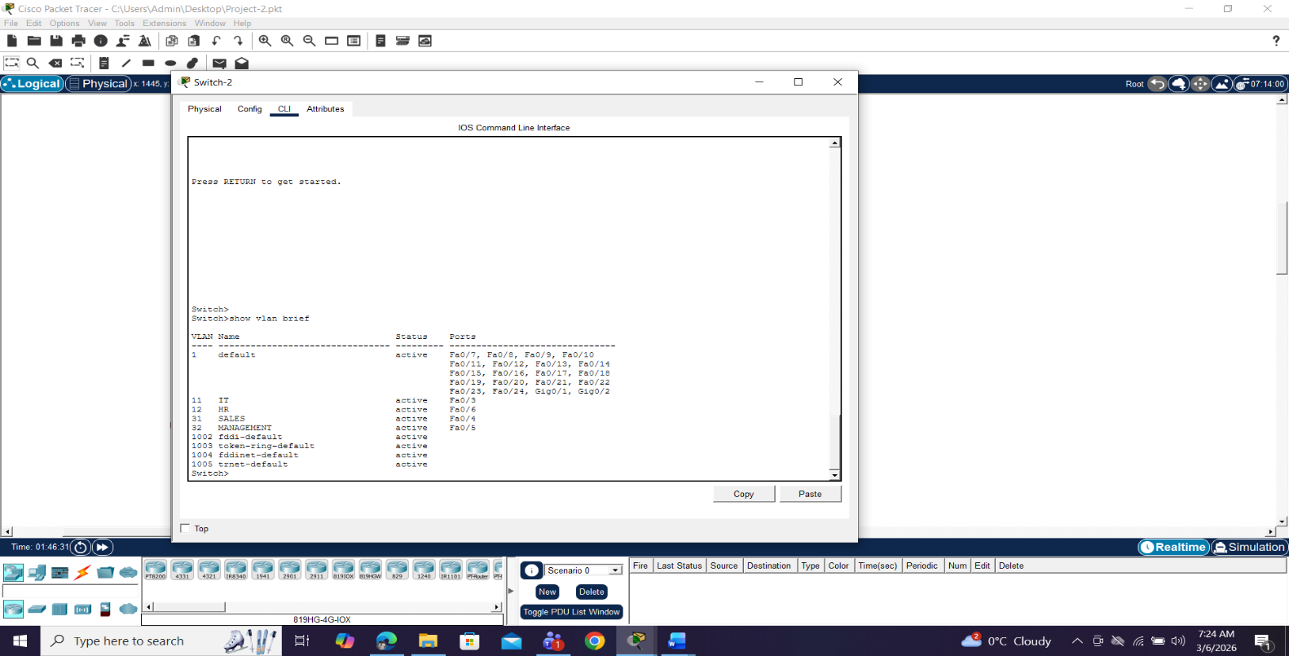
3. VLAN Configuration
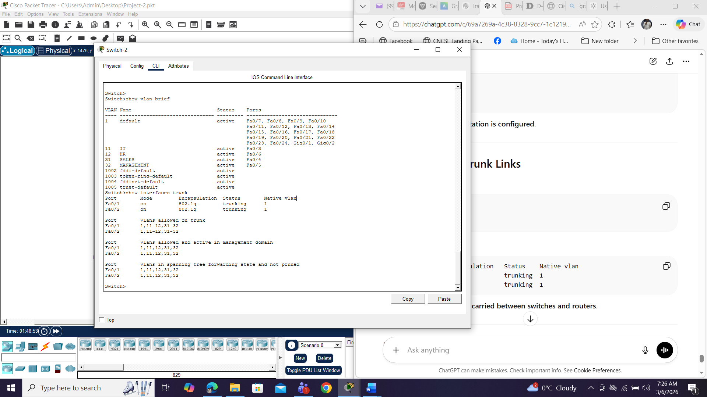
Virtual LANs were created on the switches to logically separate the network into different departments.

4. Trunk Configuration
Trunk ports were configured between switches and routers to allow multiple VLANs to travel across a single link.
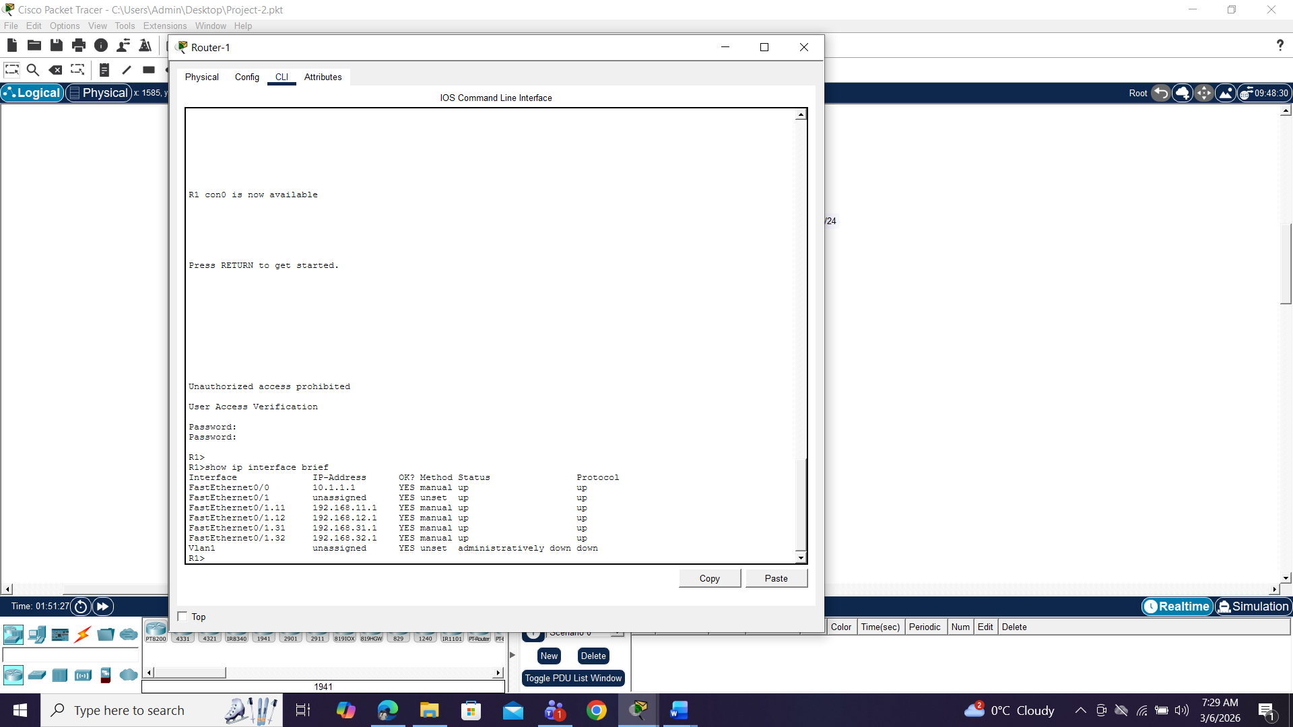

5. Router-on-a-Stick Configuration
Router-on-a-Stick was implemented on routers R1 and R3 to enable communication between VLANs.
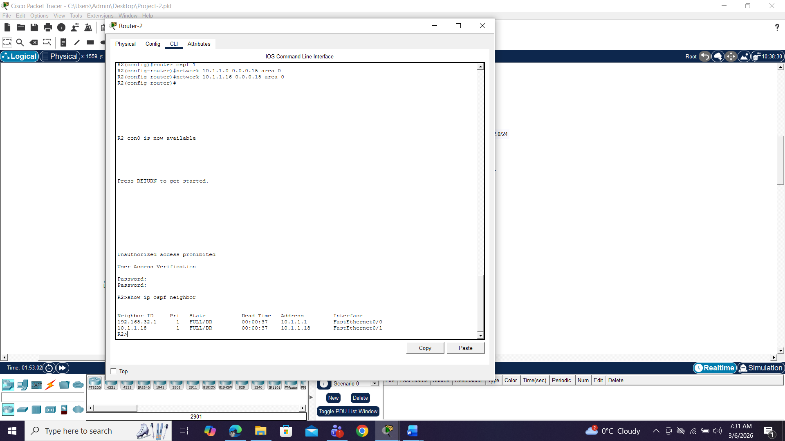

6. Dynamic Routing using OSPF
Open Shortest Path First (OSPF) was implemented between routers R1, R2, and R3 to dynamically exchange routing information.

7. Access Control List (ACL) Implementation
To enhance network security, an ACL was configured to restrict access between VLANs.
Only Laptop1 in VLAN 11 is allowed to access VLAN 32.
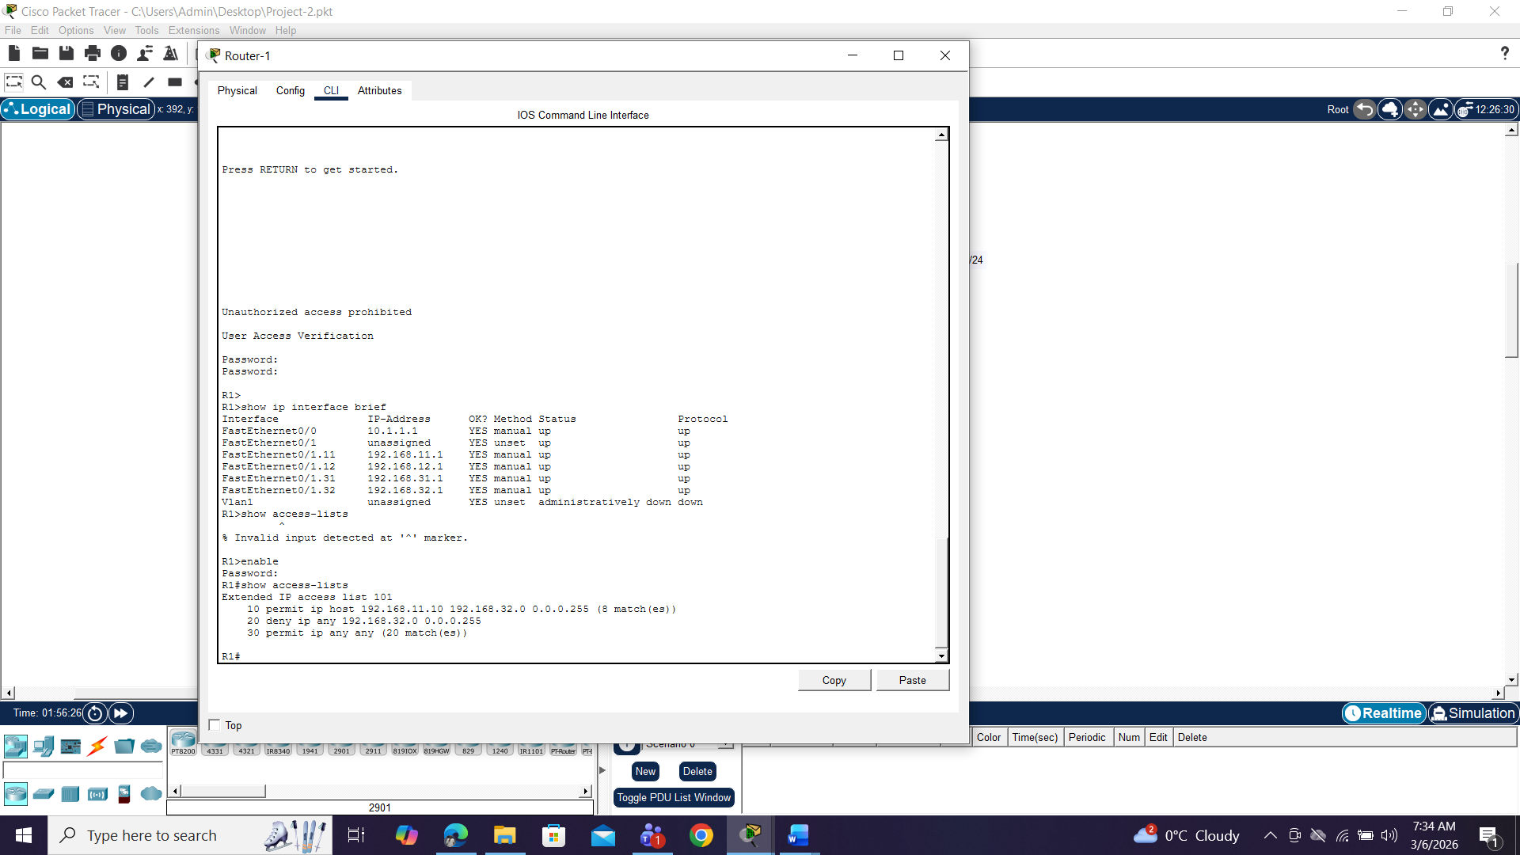

8. Network Connectivity Testing
Connectivity tests were performed using the ping command between hosts across different VLANs.

9. MAC Address Verification
Switch MAC tables were verified to confirm that devices were learned on the correct VLAN ports.
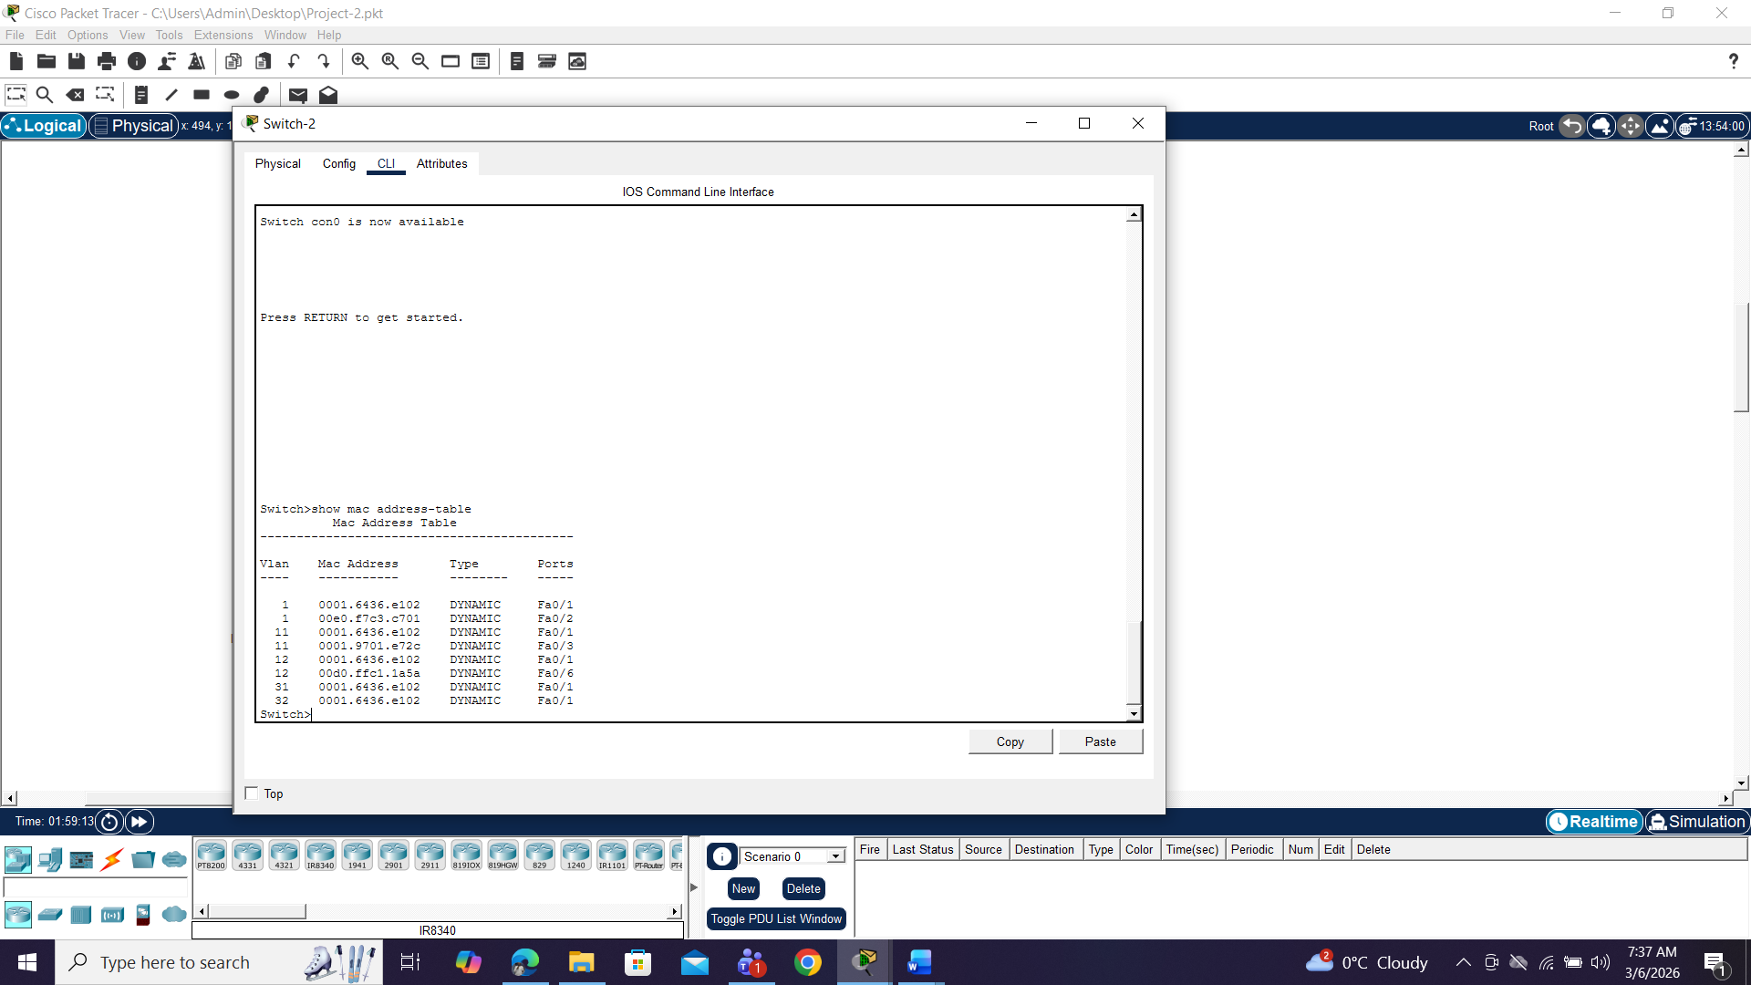

10. Conclusion
This project successfully demonstrated the implementation of a secure multi-router network using VLAN segmentation, trunk links, dynamic routing, and access control policies.
The network allows efficient communication between departments while maintaining security through VLAN isolation and ACL filtering.

